1. Changing user password

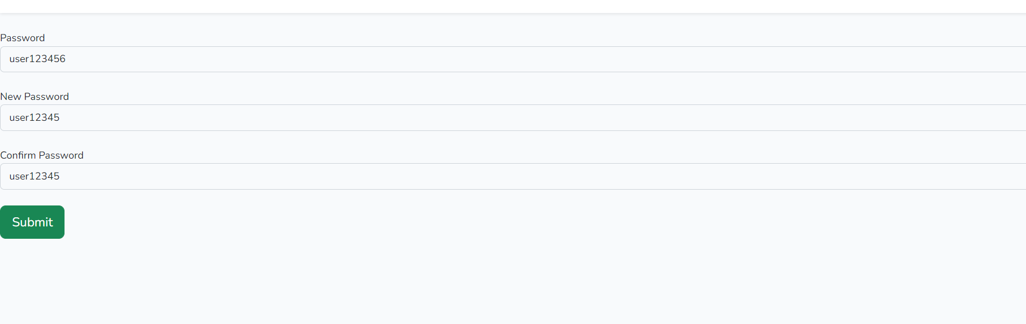

Submit gare paxi user ko password change hunxa.

Logout garera feri login garda change vhako password use garnu parxa

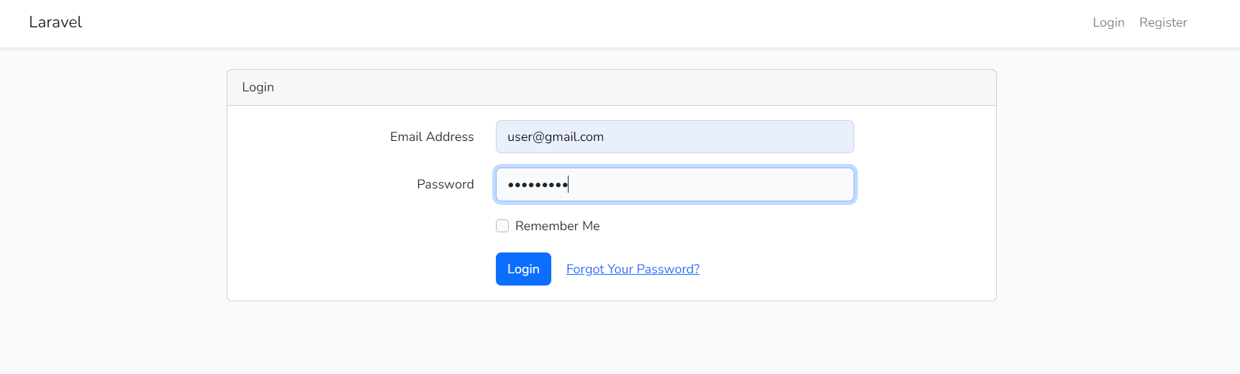

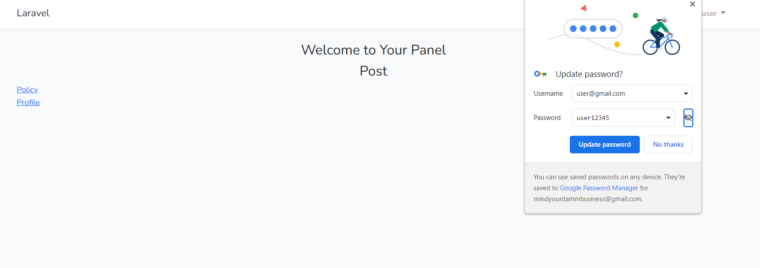

1. Two different login and Register page for Admin and Users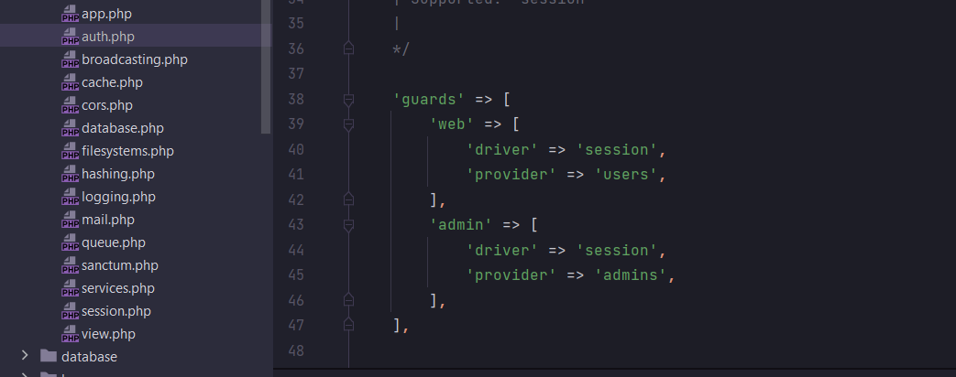

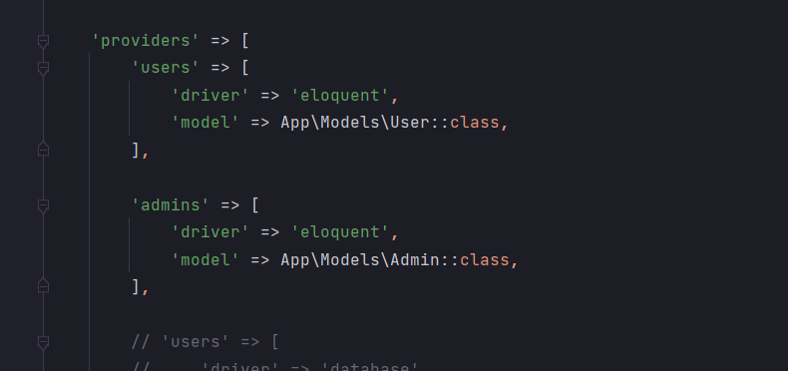

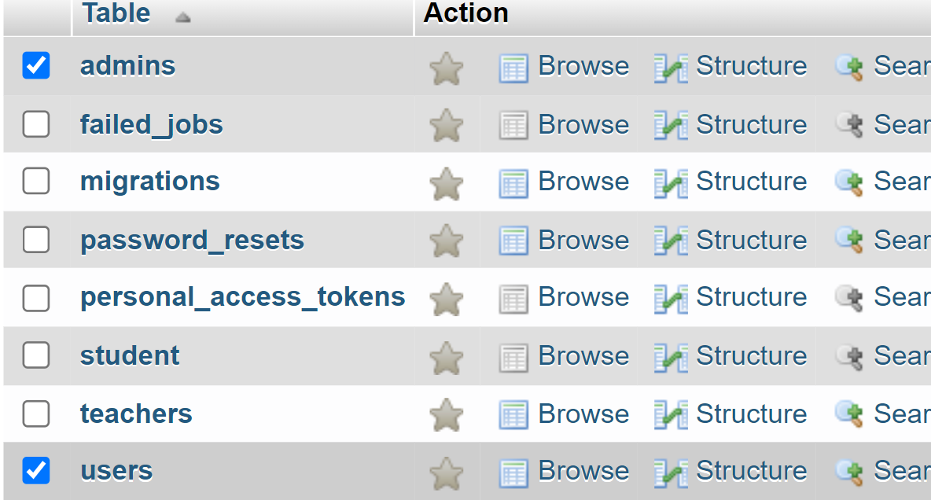

Admin Login and Register

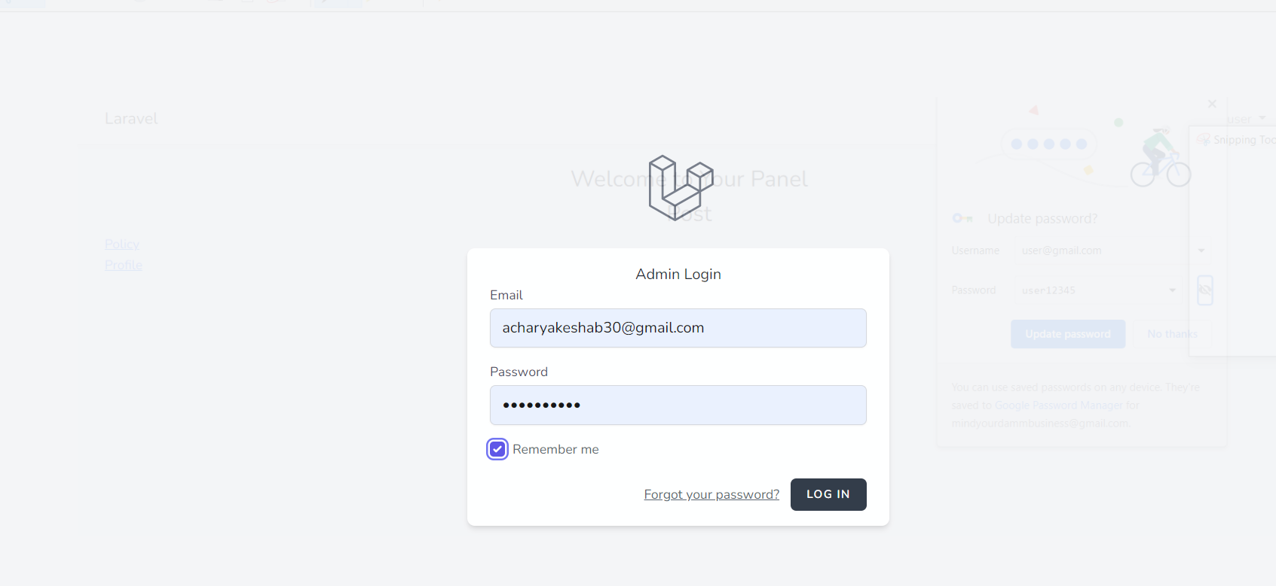

Admin Dashboard Page

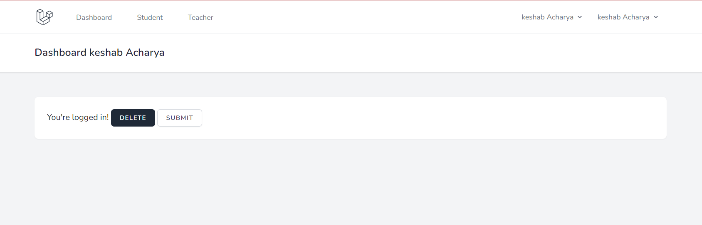

User login and Register

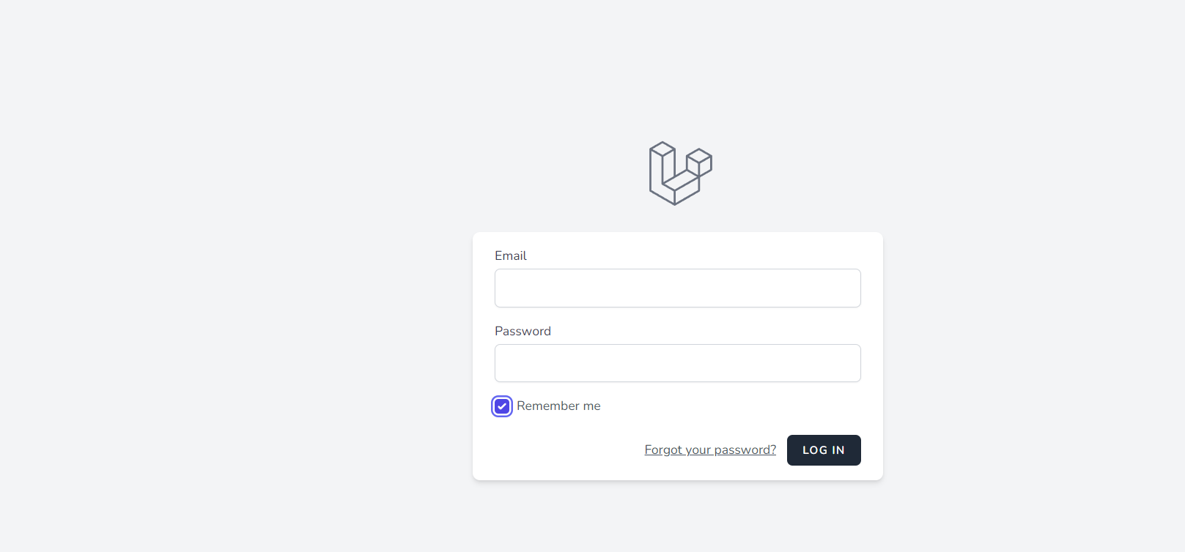

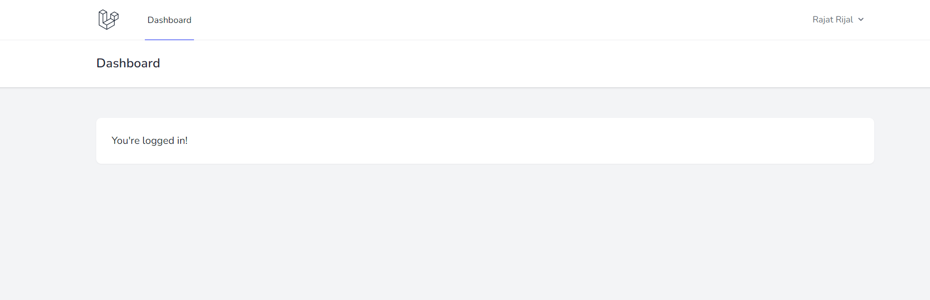

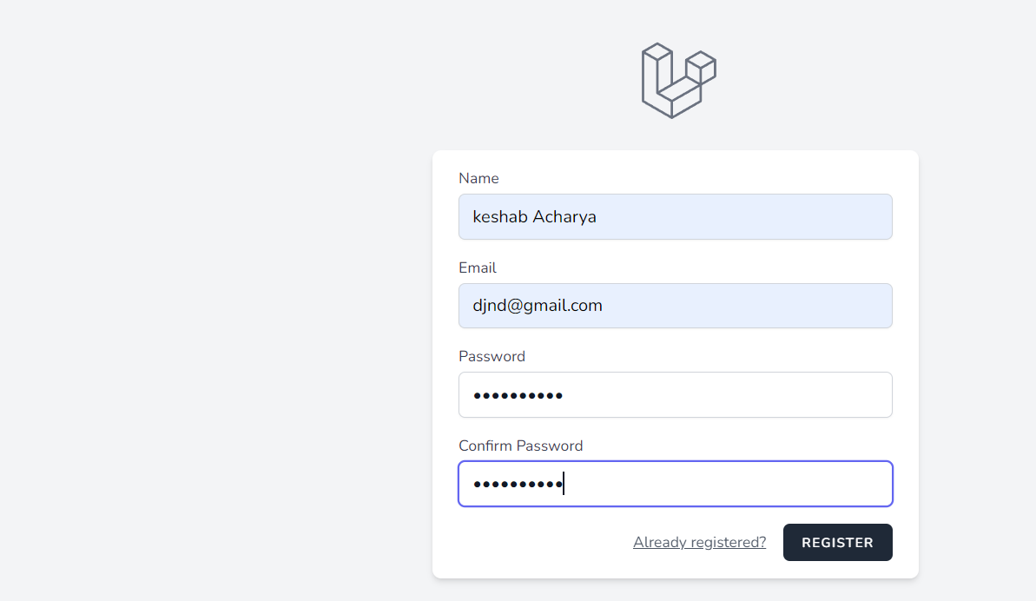

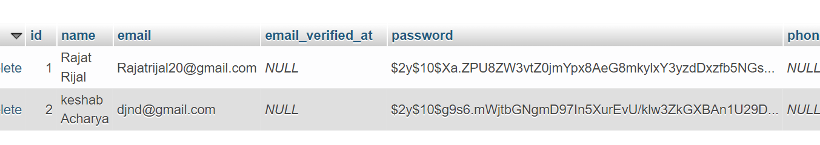

1. Mahela Laravel breeze ma garya tha aani aasti breeze ko barema herya tha aani tailwind css ko barema
2. Aaja chahi exceptional handaling ra validation ko barema herya tha

Suruma aauta service class create garya aani tha query lekhya

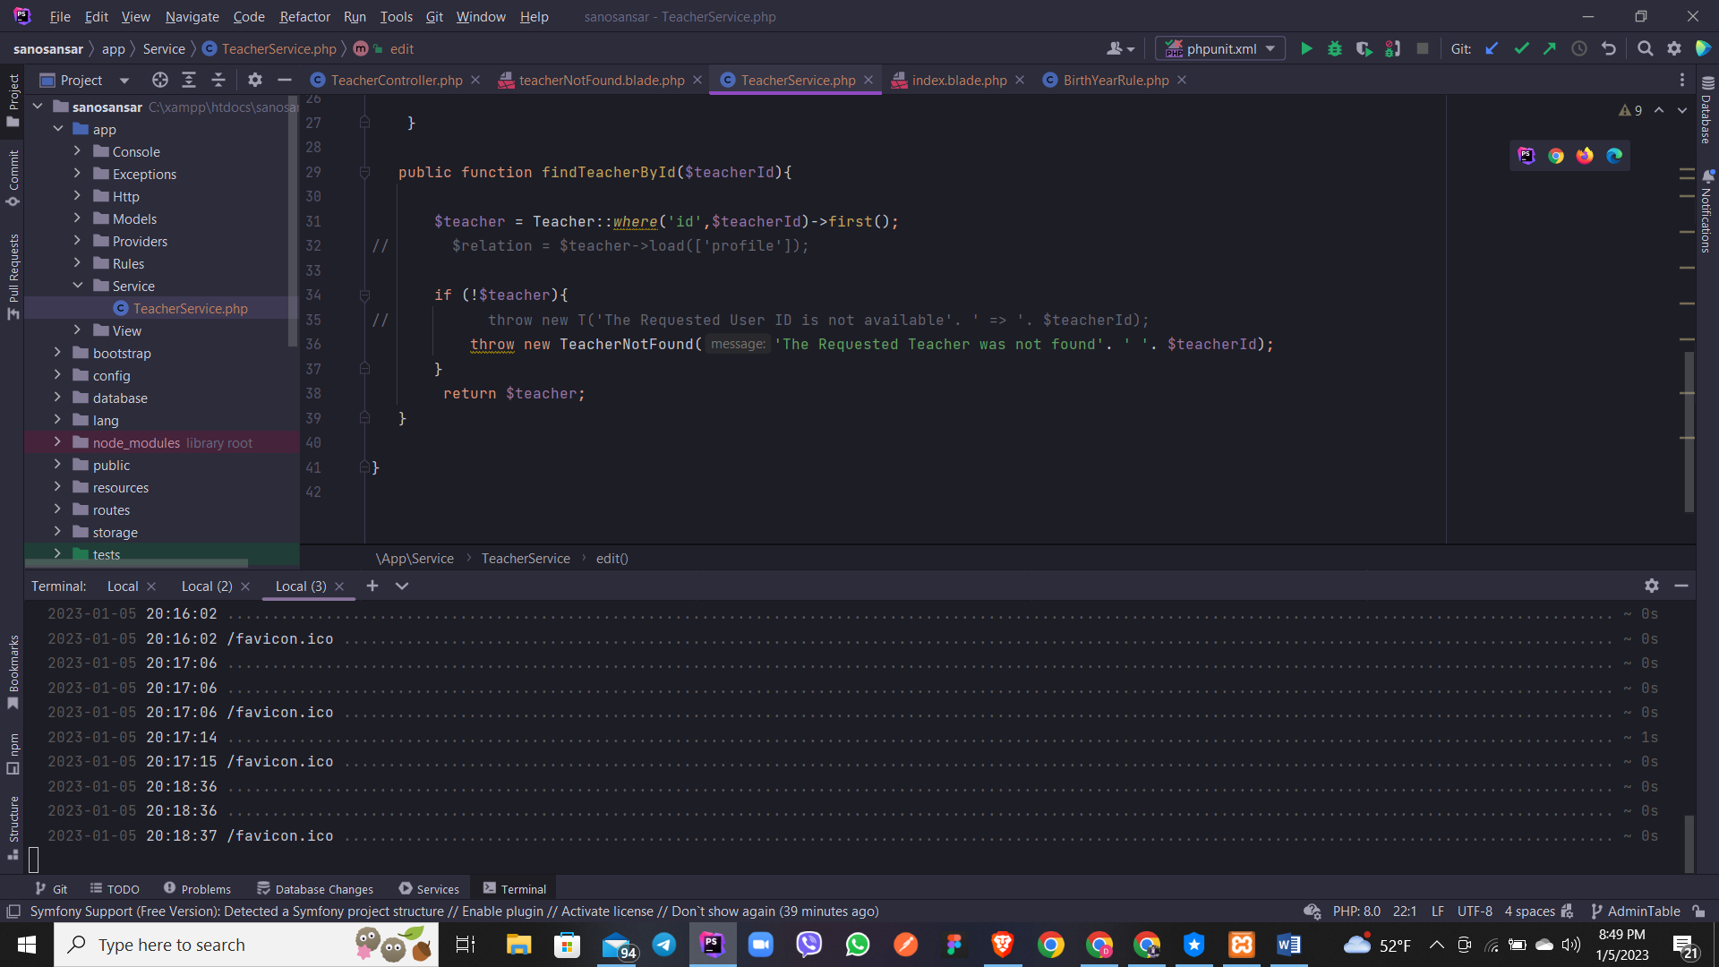

Ani tyo service class lai controller ma call garera use garya

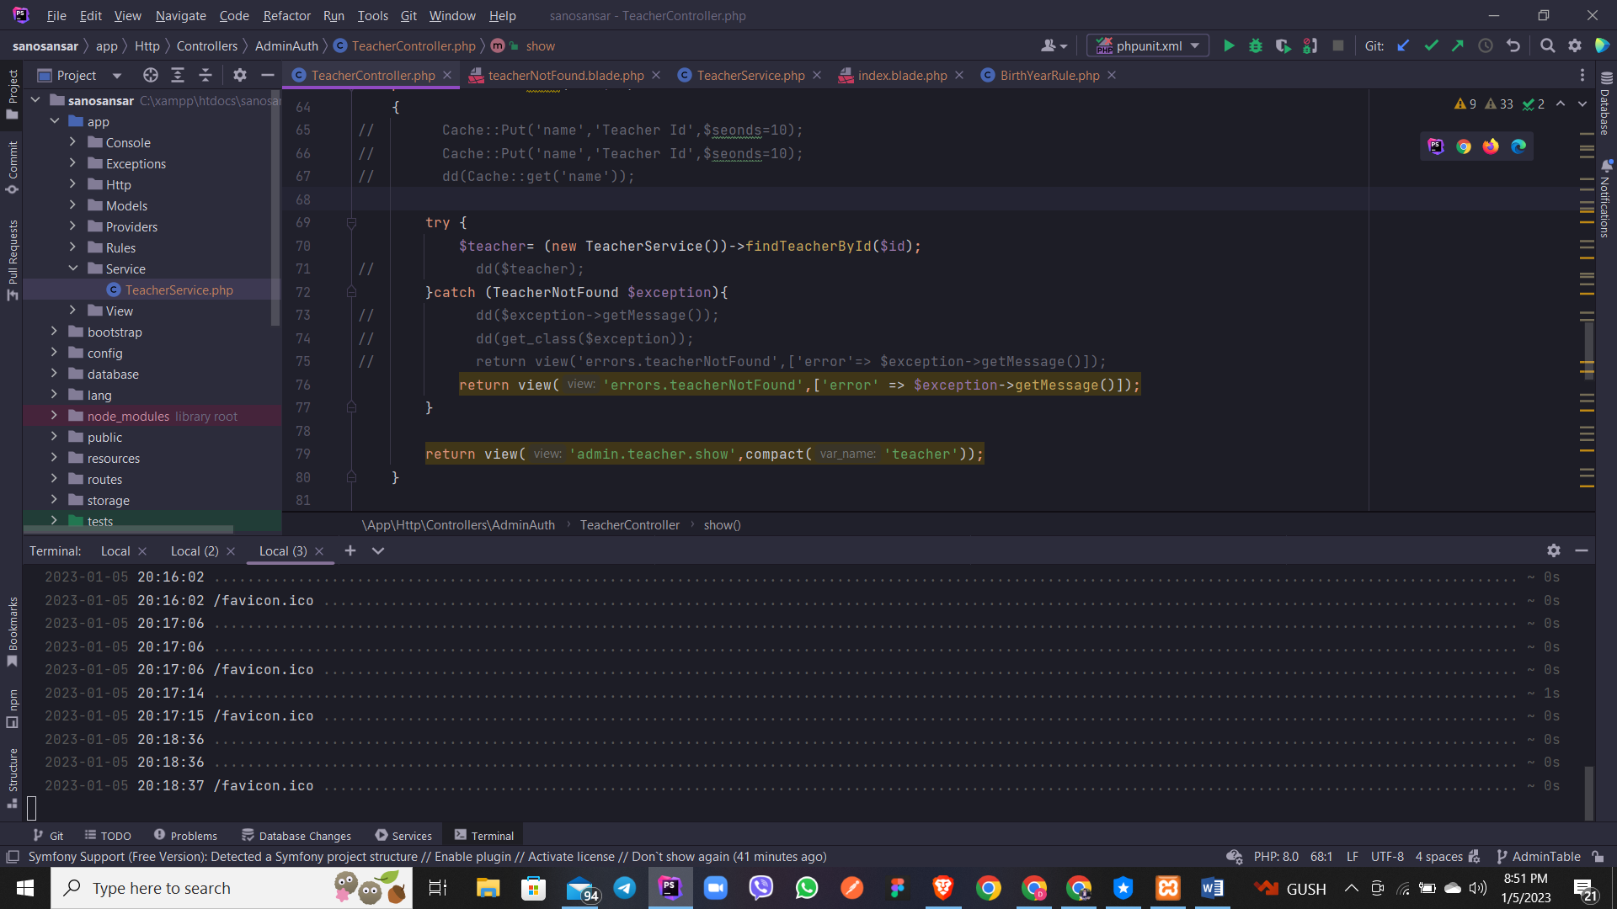

Aauta aafnai exceptional class create garya

